1. HapTouch and the 2+1 state model_ potentials of haptic feedback on touch based in-vehicle information systems

Car driving safety vibration

【Main Content】: We describe the results of a preliminary quantitative study to investigate the effects of tactile feedback on the driver’s visual attention, driving performance and operating error rate. In particular, we focus on how active tactile feedback allows the accurate interaction with small on-screen elements during driving. Our results show significantly reduced error rates and input time when haptic feedback is given.

【three levels of interactive tasks in the automotive】：**Primary, secondary and tertiary tasks**

1. The main tasks include manipulating the vehicle in terms of acceleration and deceleration and steering. This task is of paramount importance to road safety and should therefore be brought to the attention of the operator.

2. Secondary tasks are interaction with wipers and direction indicators and Advanced Driver Assistance Systems (ADAS), and they are also essential for road driving.

3. All other security-unrelated functions are third-level interaction tasks. Many of these functions (such as entertainment, communications and information applications) are implemented in the in-vehicle information system (IVIS).

【Note】: The main requirement of IVIS is not to diversify the main tasks of the driver. Therefore, IVIS must not only meet universal usability standards, but also be suitable for driving tasks

【Several tactile car screens at that time】:

Alpine3 and Immersion4 are producing haptic touch screen solutions for automotive multimedia systems. The basic principle of their systems PulsTouch and TouchSense is the movement of the entire touch screen under the user's finger.

【Buxton's description of interaction】：[2]

Buxton’s state 0 is named Out-Of-Range. An interaction has no effect on the system. State 1 is named active tracking. An example is the mouse pointer that is moved by the user. An additional signal like depressing a mouse button shifts the system into state 2 (activating, dragging). During mouse-interaction, state 0 (the Out-Of-Range condition) is undefined, because no interaction technique can be built that depends on this action (i.e. lifting the mouse from the table).

【Single Touch Screen: 2 States】：without state1

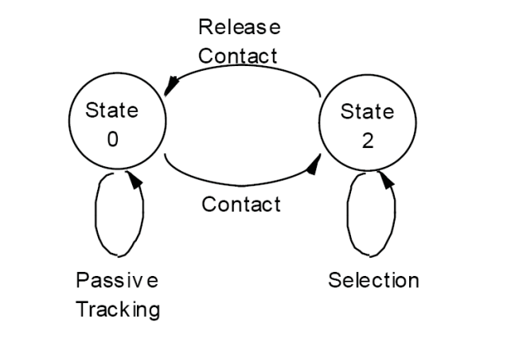

【2+1 state model】(article)

【HapTouch】：

The used system was schematically shown in Figure 4. The touch system is built up with an 8.4” color TFT Display and a surface capacitive touchscreen that was chosen to get a rigid touch surface. The entire touch system, i.e., touch input and graphic output, is controlled by a PC. To add the ability of force measurement in order to enable activation and modulation by force input, four FSR sensor elements are mounted between the corners of the display and the casing of the touch system.

【Important Refrence】

1. R. Leung, K. MacLean, M. Bertelsen, and M. Saubhasik,"Evaluation of haptically augmented touchscreen GUI elements under cognitive load," Proceedings of the 9th international conference on Multimodal interfaces, ACM, 2007, p. 374–381.

[14] M. Hall, E. Hoggan, and S. Brewster, "T-Bars: towards tactile user interfaces for mobile touchscreens," Proceedings of the 10th international conference on Human computer interaction with mobile devices and services, ACM, 2008, p. 411–414.[15]

[16] E. Hoggan, S. Brewster, and J. Johnston, "Investigating the effectiveness of tactile feedback for mobile touchscreens," Methodology, 2008.

[18] E. Hutchins, J. Hollan, and D. Norman, "Direct Manipulation Interfaces," Human-Computer Interaction, vol. 1, 1985, pp.

311- 338.

[22] J. Lee and C. Spence, "Assessing the benefits of multimodal feedback on dual-task performance under demanding conditions", Proceedings of the 22nd British HCI Group Annual Conference on HCI 2008: People and Computers XXII: Culture, Creativity, Interaction-Volume 1, British Computer Society, 2008, p. 185–192.

[24] K. Bach, M. Jæger, M. Skov, and N. Thomassen, "You can touch, but you can't look: interacting with in-vehicle systems," Proceedings of CHI, 2008, p. 1139.